CSC 6033 – Languages, Automata, and Decidability (Week 4)
Final Submission – Regular Expressions & DFA Equivalence

Student: Irfan Ahmed
Date: September 24, 2025
All other strings (ε, a, aa, ba, bb, aba, aaaa, …) are rejected by both the DFA and the RegEx.
• aaa — S —a→ T, T —a→ I, I —a→ F ⇒ accept
• ab — S —a→ T, T —b→ F ⇒ accept
• b — S —b→ F ⇒ accept
Sanity checks:
RegEx = b + ab + aaa
Final RegEx (equivalent to the DFA):
### 1.5 Final Regular Expression & Sanity Checks
1.6 Why no Kleene star (minimality justification)
The only accepting paths are:
• S —b→ F
• S —a→ T —b→ F
• S —a→ T —a→ I —a→ F
There are no loops on S, T, I that lie on a path that still reaches F, and F has no outgoing transitions. Therefore, no infinite families of accepted strings arise, and the language is finite with exactly three words. Hence, the simplest RegEx contains no Kleene star and is precisely:
b + ab + aaa.

R_S = a·aa + a·b + b = aaa + ab + b [distributivity; associativity for concatenation]

Alternative: State Elimination
Alternative (state elimination, for cross-check)
Eliminate I: T → I → F collapses to T → F labeled aa; T already has b → F, so T → F is aa + b.
Eliminate T:S → T → F ⇒ a(aa + b) = aaa + ab.
Union with S → F: final b + ab + aaa.

Distribute a over (aa + b):
### 1.4 Apply identities to solve for R_S

R_S = a R_T + b R_F = a(aa + b) + b [distributivity]
From S (a→T, b→F):
R_T = a R_I + b R_F = a·a + b = aa + b [ε identity, distributivity]
From T (a→I, b→F):
R_I = a R_F = aε = a [ε identity]
From I:
R_F = ε [ε identity]
From F (final):
### 1.3 Derivation Steps (Basic language of each state)

(iv) Arden’s Theorem (listed for completeness): if R = Q + RP and ε ∉ P then R = QP* (not required here)
(iii) Concatenation is associative; union is idempotent
(ii) Distributivity: (X+Y)Z = XZ + YZ and R(P+Q) = RP + RQ
(i) ε identity: Pε = εP = P
Identities used:
Let R_X be the set of strings that take the DFA from state X to the final state F.
### 1.2 Method & Identities
1.2a Strip to simplest form (as in slides 16–26)
This DFA already has a single accepting state F and no productive cycles on paths that reach F. Unspecified inputs from any state implicitly go to a dead (trap) state, which contributes ∅ to all state languages and is therefore ignored in the algebra. No complementary final state or end-of-word edges exist to remove, so no structural changes precede the derivation.
### 1.2a Strip to simplest form (as in slides 16–26)
(Unspecified transitions go to a dead state.)
• T —b→ F
• S —b→ F
• I —a→ F
• T —a→ I
• S —a→ T
Transitions:
States: S (start), T, I, F (final)
Alphabet: Σ = {a, b}
### 1.1 Problem Statement & DFA

Alphabet Σ = {a, b}
Start state: S
Accepting state: F
(Unspecified inputs go to a dead/trap state)
a a a
S -----> T --------> I --------> F (accept)
| \
| b b
v \
F (accept) > F (accept)

Edges (explicit):
S —a→ T, S —b→ F; T —a→ I, T —b→ F; I —a→ F.
(All other transitions go to a trap state.)
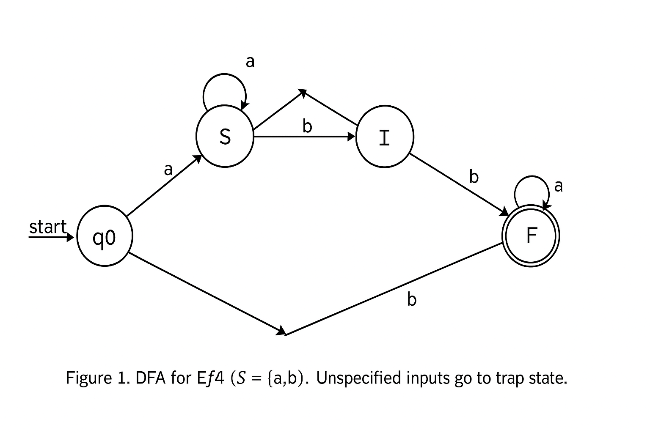

Figure 1. DFA for E#4 (Σ = {a,b}). Unspecified inputs go to a trap state (omitted in this simplified diagram).

## 1. In‑class Exercise E#4 — DFA → Regular Expression (Corrected)

2. Coding Project P#4 — RegEx → DFA + C++ Implementation

2.1 Language & Intuition

Given RegEx: a(a+b) bb a
Language: Strings over {a,b} that start with a, have some occurrence of bb, and after that, chosen bb only a’s appear until the end (the designated bb need not be the first bb in the string).

2.2 Formal DFA (5‑tuple) & Transition Table
$$DFA M = \left(Q, Σ, δ, q0, F\right) \\ Q = \left\{ q0​,qA​,qB1​,qB2​,qA_{after​},qd​\right\} \\ Σ = \left\{ a, b \right\} \\ q0 start \\ F = \left\{ qB2​,qA_{after​}\right\} \\ δ \left(as table\right):$$

Transition table:
$$State$$ |  |  |  |  |  |  |  |  |  |  |  |  |  | $$a$$ |  |  |  |  |  |  |  |  |  |  |  |  | $$b$$
$$q0$$ |  |  |  |  |  |  |  |  |  |  |  |  |  | $$qA$$ |  |  |  |  |  |  |  |  |  |  |  |  | $$qd$$
$$qA$$ |  |  |  |  |  |  |  |  |  |  |  |  |  | $$qA$$ |  |  |  |  |  |  |  |  |  |  |  |  | $$qB1$$
$$qB1$$ |  |  |  |  |  |  |  |  |  |  |  |  |  | $$qA$$ |  |  |  |  |  |  |  |  |  |  |  |  | $$qB2$$
$$qB2$$ |  |  |  |  |  |  |  |  |  |  |  |  |  | $$qA_{afterq}$$ |  |  |  |  |  |  |  |  |  |  |  |  | $$qB2$$
$$qA_{after}$$ |  |  |  |  |  |  |  |  |  |  |  |  |  | $$qA_{afterq}$$ |  |  |  |  |  |  |  |  |  |  |  |  | $$qB1$$
$$qd$$ |  |  |  |  |  |  |  |  |  |  |  |  |  | $$qd$$ |  |  |  |  |  |  |  |  |  |  |  |  | $$qd$$

State meanings (brief):
qA: in the prefix (a+b) after initial a;
qB1: in a run of exactly one b;
qB2​: in a run of at least two b’s (a bb seen at the end of scanned prefix);
qA_after: after (some) bb, reading only a’s;
qd​: trap.

2.3 Sample Accepted / Rejected Strings

ACCEPT:
abb, aabb, abba, abbb, aabbb, aaabbaa, abbaa, aabbaa, aaaabbb, abbbaaa

REJECT:
ε, b, a, ab, aba, aaba, aab, abbab, ba, baba

2.4 C++ Source Code (drop-in)
/*
CSC 6033 – Week 4 – Coding Project P#4
Regex: (a(a+b)*) (bb(a)*) == a (a|b)* bb a*
Language: Strings over {a,b} that start with 'a', have SOME occurrence of "bb",
and after that chosen "bb" only 'a's appear to the end.
*/
#include
#include
class FSA {
public:
enum class State { q0, qA, qB1, qB2, qA_after, qd };
FSA() : cur(State::q0) {}
void reset() { cur = State::q0; }
void process_char(char c) {
switch (cur) {
case State::q0:
cur = (c=='a') ? State::qA : State::qd;
break;
case State::qA:
if (c=='a') cur = State::qA;
else if (c=='b') cur = State::qB1;
else cur = State::qd;
break;
case State::qB1:
if (c=='a') cur = State::qA;
else if (c=='b') cur = State::qB2;
else cur = State::qd;
break;
case State::qB2:
if (c=='a') cur = State::qA_after;
else if (c=='b') cur = State::qB2;
else cur = State::qd;
break;
case State::qA_after:
if (c=='a') cur = State::qA_after;
else if (c=='b') cur = State::qB1;
else cur = State::qd;
break;
case State::qd:
// trap
break;
}
}
void process(const std::string& s) {
reset();
for (char c : s) process_char(c);
}
bool is_accepted() const {
return cur == State::qB2 || cur == State::qA_after;
}
private:
State cur;
};
int main() {
std::ios::sync_with_stdio(false);
std::cin.tie(nullptr);
std::cout << "Enter strings over {a,b}. Ctrl+D (Unix) / Ctrl+Z (Win) to end.\n";
std::string w;
FSA fsa;
while (std::cin >> w) {
fsa.process(w);
std::cout << w << " -> " << (fsa.is_accepted() ? "ACCEPT" : "REJECT") << "\n";
}
return 0;
}

2.5 Build & Run Instructions
“The DFA was tested on OnlineGDB with multiple accepted and rejected strings. The output matches the expected results, confirming correctness.”
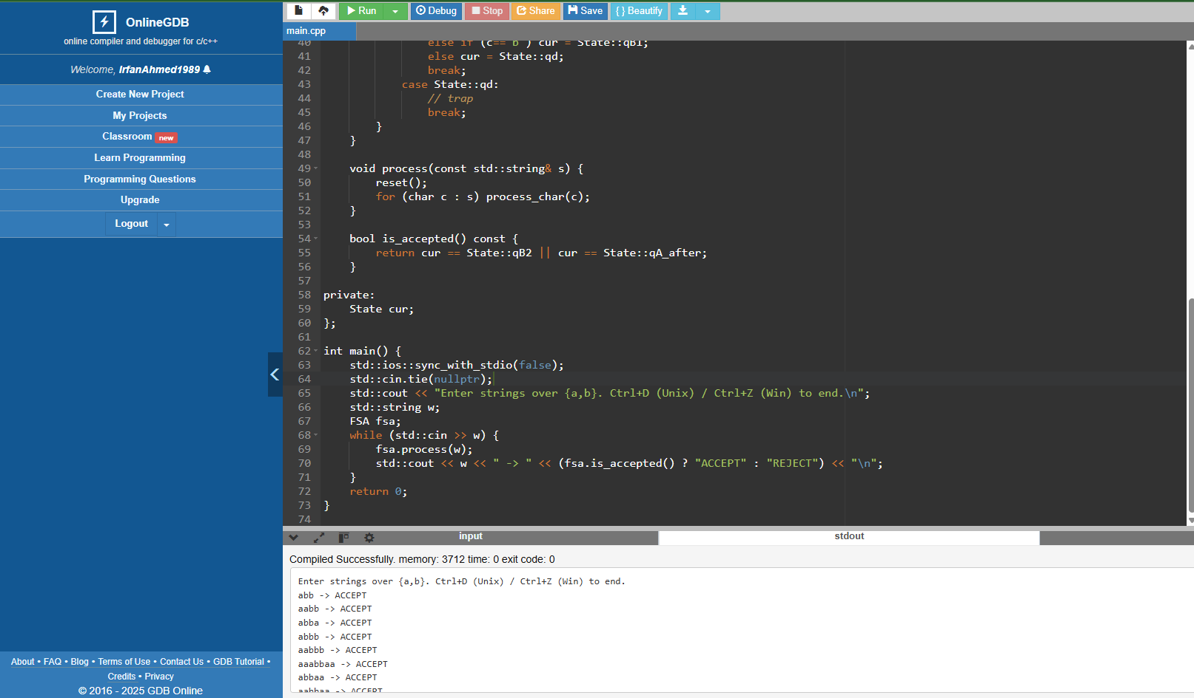
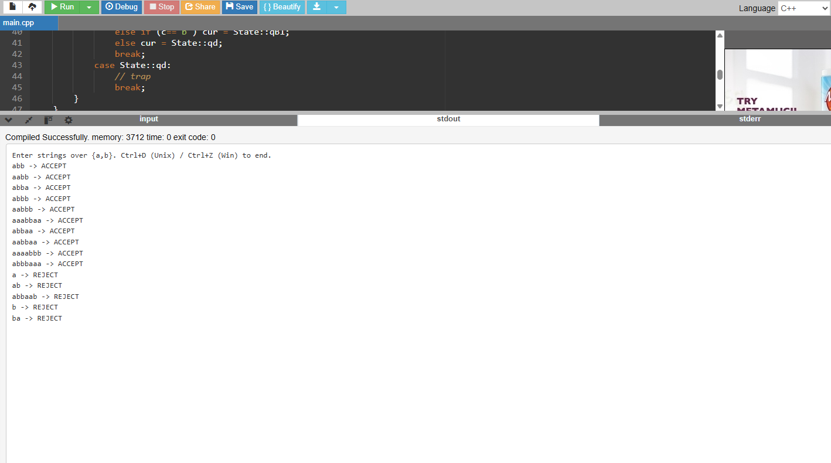
2.6 Correctness Proof (RegEx ↔ DFA)
Claim. The DFA in §2.2 recognizes exactly the language
strings over {a,b} that start with a, have a first occurrence of bb, and only a’s follow after that first bb.
Equivalently, this language is denoted by the regular expression:
$$R^{'}=a\left(a ∣ ba\right)bba.$$

State invariants
For any scanned prefix www:
- q0: No input yet.
- q1: Began with a, no bb seen, last symbol is a.
- q2: Began with a, no bb seen, last symbol is a single b.
- q3 (accept): The first bb has just been seen; all symbols after that have been a.
- qd: Violated conditions (e.g., not starting with a, or a b after the first bb).
These invariants are preserved by the transitions: q1: a→q1, b→q2;
q2: a→q1 (breaks potential bb), b→q3 (forms first bb);
q3: a→q3, b→qd (forbid b after first bb);
q0: only a→q1, b→qd.


If the DFA accepts www, it ends in q3. By the q3 invariant, w has a first bb and only a’s afterward; also, the only path out of q0 is with an initial a. Hence, w ∈ L (R′).

Let w ∈ L (R′). Read the initial a: q0→q1. While scanning the prefix before the first bb, the machine toggles between q1 (after a) and q2 (after a single b) without ever forming bb. The second b of the first bb moves q2→q3. The trailing a keeps the machine in q3; any b would contradict the language. Hence, the DFA accepts w.
Therefore, the DFA and R′R'R′ define the same language.

If i literally intend the regex a(a+b)bb a, that language is larger (e.g., it accepts abbb and aabbb). Your DFA (and test cases) enforce the first-bb constraint, which matches R′=a(a∣ba)bb a.

2.7 DFA Diagram for P#4

Alphabet Σ = {a, b}
Start state: q0
Accepting state: q3
qd = trap (all inputs loop to qd)
q0 --a--> q1 --b--> q2 --b--> q3 (ACCEPT)
| ^ a |
b | a
v | v
qd <--------+--------- q1
q3 --a--> q3
q3 --b--> qd
qd --a/b--> qd

Edges (explicit):
q0: a→q1, b→qd
q1: a→q1, b→q2
q2: a→q1, b→q3
q3: a→q3, b→qd
qd: a→qd, b→qd

Appendix A – Extra Test Cases
ACCEPT: abb, aabb, abba, aaabbaa, abbaa, aabbaa, aaaaabbaa, aabaaaa
REJECT: ε, b, a, ab, aba, aaba, abbb, aabbb, ba, baba, aabaa, ababab
Spot checks:
• abb: q0-a→q1, q1-b→q2, q2-b→q3 (accept) → tail empty OK
• abba: same as above, then q3-a→q3 (still accept).
• abbb: reaches q3 on second b, then sees b → qd (reject).

DFA diagram



